BIKE STATION
Project Overview and Objective
This project involves cleaning, transforming, and analysing raw data using Power BI and creating a dashboard to derive meaningful business insights.
The main objective is to demonstrate data pre-processing techniques using Power BI and dashboard visualization to make informed decisions.
________________________________________
Problem Statement
- Analyse bike availability across different stations and cities.
- Monitor the status of stations (Open/Closed).
- Identify stations with no bikes or low bike availability.
- Determine the utilization of bike stands and empty docking stations.
- Compare bike availability across different contracts/cities.
- Provide geographical insights using latitude and longitude data.
Attribute
Attributes | Data Type | Discription
Number | Numeric | Number of bike purchase
Name | Text | Station name
Address | Text | Station address
Position | Numeric | Station direction
Bonus | Text | Bonus station
Status | Text | Station status
Banking | Text | Payment status
Contract name | Text | City / service area
Bike stands | Numeric | Total bike stands
Available bike stands | Numeric | Available bike stand
Available bike | Numeric | Available bike
Last update | Date | Last purchase

________________________________________
Tools & Technologies
Power BI: Data cleaning, Data modelling, DAX calculations, visualization, and interactive dashboard creation.
______________________________________
Tasks Performed
- Data Cleaning & Transformation: Removed duplicates, handled missing values.
- DAX formula created
- Dimensional and fact table created
- Relationship across tables.
________________________________________
Data Modelling
SCREENSHOT OF DATA MODELLING
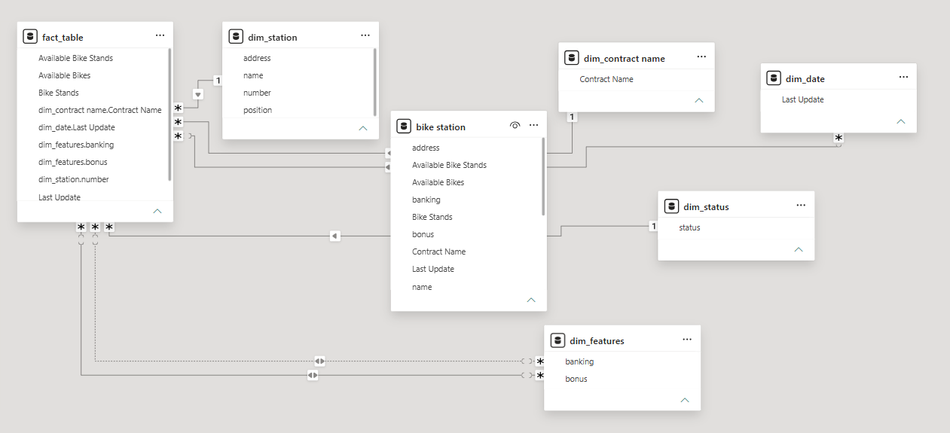

_______________________________________
SCREENSHOT OF DASHBOARD
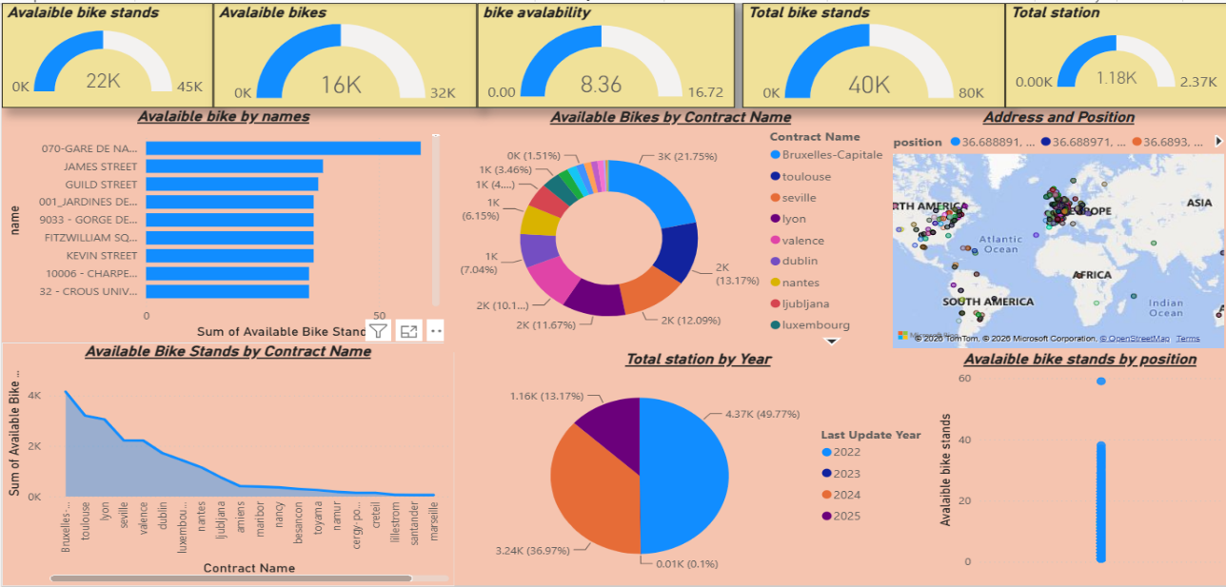
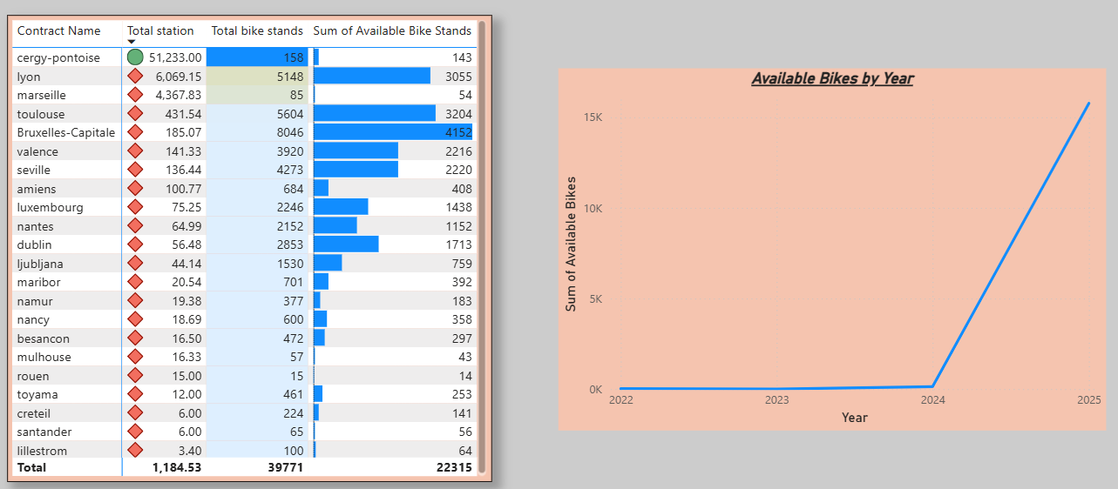
Insights
- Total number of stations
- Total bike stands and available bikes
- Number of open and closed stations
- Bike availability by city and station
- Stations with high numbers of empty stands
- Comparison of bike availability across different cities
Conclusions
Power BI proved effective for end-to-end data analysis, from raw data to visual reporting Bike stations across the locality.

